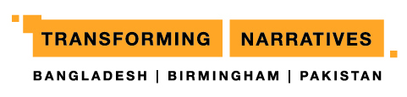

Website Event Submission Template

The events section of the Transforming Narratives website will showcase a broad range of artistic/cultural work of Bangladeshi and Pakistani origin happening in Birmingham, as well as events taking place in partner cities in Bangladesh and Pakistan. If you have an event that would be suitable to feature on the site, please complete this form:

Name of event:

Organisation presenting the event:

Date/s and times:

Venue name and address:

Marketing copy (up to 150 words):

Website URL:

Ticket prices:

Booking details (website, box office telephone):

Age guidance:

Relevant social media accounts to be tagged into posts about the event:

Instagram:
Twitter:
Facebook:

Any other details:

Name and contact details for event marketing contact (not for publication on website):

Please return this form along with at least one good quality high resolution image to illustrate the event, to stephbrownmarketing@gmail.com.

Disclaimer: We aim to profile as many relevant events as possible on the Transforming Narratives website. Events that are not part of the TN programme will be included at the discretion of the TN management team, based upon their relevance to the aims of the project, and the quality and nature of the event.

